

**WE Lab Manual Solution**

**Submitted By : 20CS039**

**Submitted To: Engr: Kunooz Fatima**

**PRACTICAL # 01**

**TO PRACTICE THE BASIC TAGS OF HTML**

**LAB TASKS**

**Task #1:** What is Html? Discuss what is difference between html tags and html element?

**ANS:** HTML is the standard language used to create documents on the World Wide Web, it is used to structure content on web pages. HTML consists of a set of tags and elements that define the structure and presentation of web content.

HTML tags are keywords enclosed in angle brackets (**<** and **>**) that specify the structure and formatting of content within a web page. Tags are used to define elements and their properties. For example, the **<p>** tag is used to define a paragraph, the **<h1>** tag is used for a top-level heading, and the **<a>** tag is used for hyperlinks.

**Task # 2**: Make a webpage which will show your bio data (e.g: Name, fathers name, class, roll no, address, contact no, email address etc.). Use headings etc.

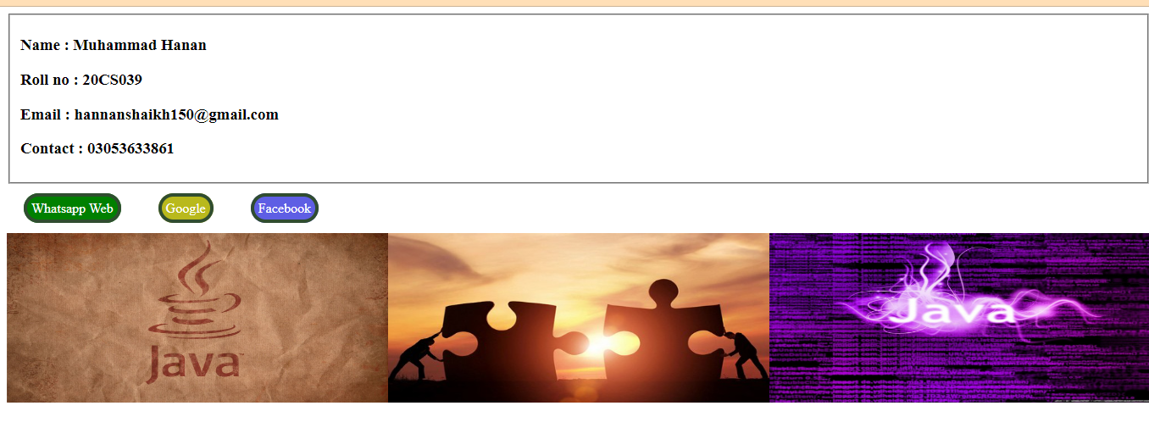

**Task # 3:** Apply 3 web links on your web page. Also place at least 3 images.



**Task # 4:** Make a web page which will show page header, body & footer. Size of header should be same as footer. Apply some font attributes in body section

